CS-3083 Project 3 Report

Bradley Titagwan

Task 1: Inference Algorithms for Bayesian Networks
Part 1: Algorithm Descriptions
- Elimination-ASK (Exact Inference): This algorithm performs exact inference by reformulating the joint probability distribution as a product of factors. Instead of computing the full joint distribution, which grows exponentially, it systematically eliminates "hidden" variables—those not in the query or evidence—one at a time. This is done by summing over the variable's possible values and creating a new factor that represents the marginal distribution. The process continues until only the factors involving the query variable remain. These are multiplied and normalized to provide the exact posterior probability.
- Likelihood-Weighting (Approximate Inference): This is an important sampling technique designed to handle evidence efficiently. In topological order, it generates a sample for every non-evidence variable based on its parents' values. However, for evidence variables, the algorithm does not sample; it fixes the variable to its observed value. To account for the fact that these samples are not drawn from the actual distribution, each sample is assigned a weight. This weight is the product of the probability of each evidence variable given to its parents. The result is the normalized sum of weights for each possible value of the query variable.
- Gibbs-ASK (Approximate Inference): Gibbs sampling is a Markov Chain Monte Carlo (MCMC) method. It begins with a random state where evidence variables are fixed. It then moves through the state space by picking a non-evidence variable and resampling its value while keeping all other variables constant. The new value is sampled according to the distribution of that variable conditioned on its Markov Blanket (its parents, children, and children’s other parents). By repeating this thousands of times, the "walk" through the states eventually reflects the true posterior distribution, even in highly complex networks.

Part 2: Manual Calculation: P(A | D = true)
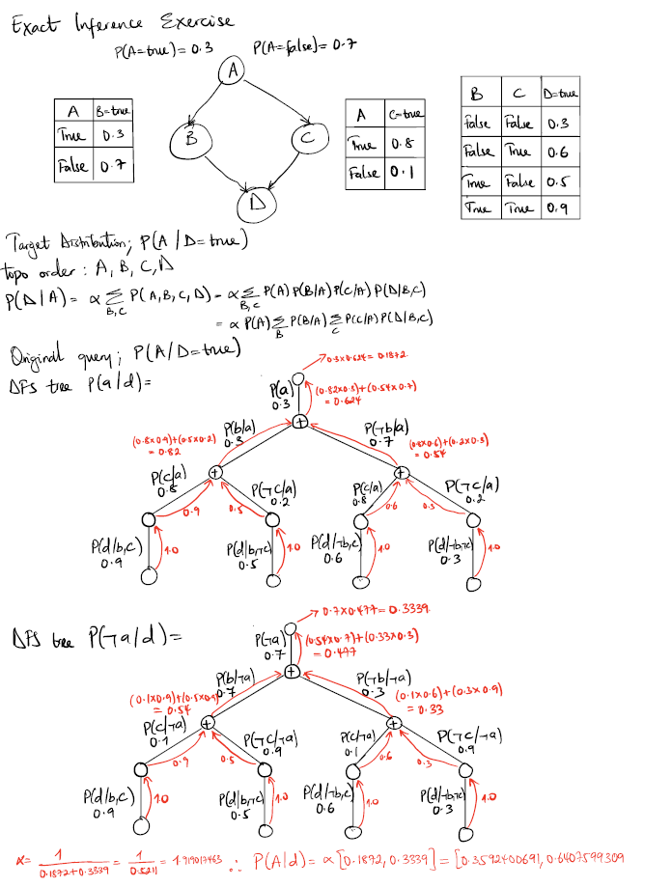
Comparing the results of my manual calculation of the 4-node network query P( A | D=true} with the output of the program, I was very accurate up to the ninth decimal place before I rounded up.
Part 3: Comparative Analysis

4-Node Bayesian Network Convergence Comparison
The Convergence Comparison plot illustrates a stark difference in how these two algorithms approach the "Exact" dashed line:
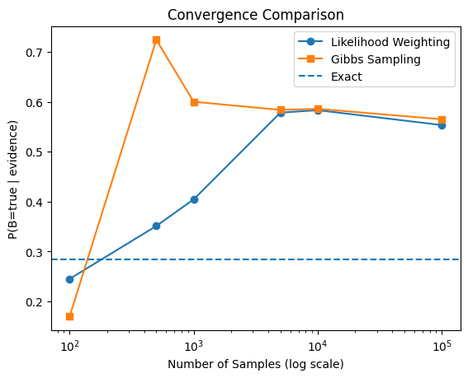
- Gibbs Sampling Stability: Gibbs sampling exhibits much higher accuracy at lower sample counts. Even at N=100, it is within a reasonable range of the true value. As N reaches 100,000, the error becomes negligible (0.0011), showing a very smooth and reliable convergence curve.
- Likelihood Weighting Volatility: LW shows extreme variance. At low N (100–500), it failed to capture the distribution entirely, returning 0.0. At N=1,000, it overshot the target significantly (0.835). While it eventually stabilizes near the correct answer at N=10,000, it remains more susceptible to fluctuations than Gibbs.
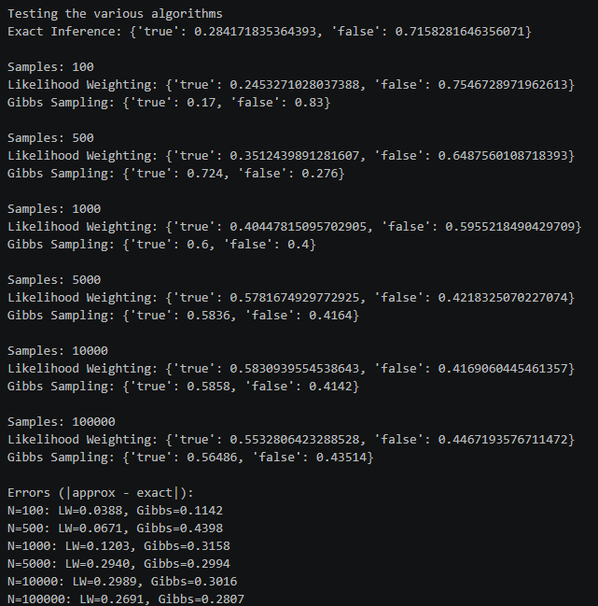

15-Node Bayesian Network Convergence Comparison
The Convergence Comparison plot for the 15-node Bayesian Network demonstrates that both sampling algorithms converge toward the exact posterior probability as the number of samples increases, though their convergence characteristics differ.
- Gibbs Sampling Stability: Gibbs Sampling initially overestimates the posterior probability at low sample counts (N = 100–500), but its estimates steadily improve as additional samples are generated. By N = 10,000, Gibbs Sampling has converged very closely to the exact inference value, with only a minimal error remaining. This behavior demonstrates the algorithm's strong long-term stability and reliability for larger Bayesian Networks.
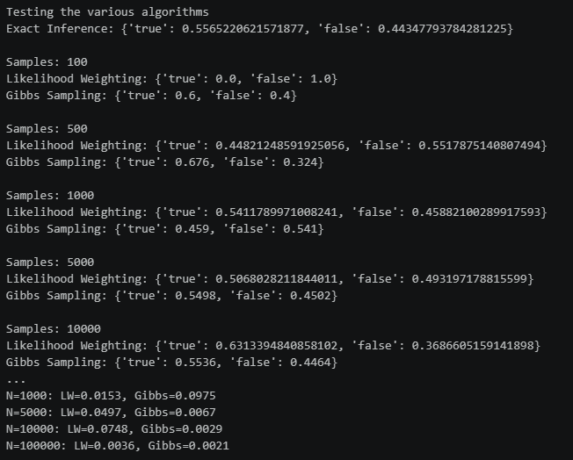
- Likelihood Weighting Convergence: Likelihood Weighting exhibits greater variability during the early stages of sampling. At N = 100, it completely misses the target distribution, producing an estimate of 0.0. As the sample size increases, however, its approximation rapidly improves, approaching the exact posterior probability. By N = 100,000, the algorithm has converged closely to the exact
inference result, although it remains 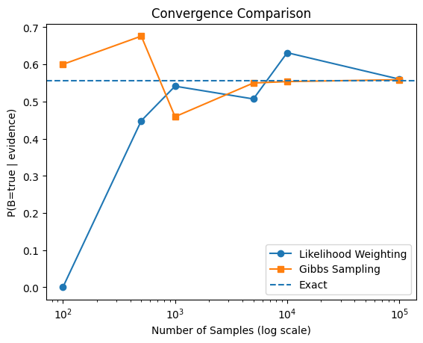somewhat more sensitive to sample variance than Gibbs Sampling throughout the experiment.
Overall, both algorithms demonstrate convergence toward the exact posterior probability as the number of samples increases, confirming the consistency of approximate Bayesian inference methods even in a substantially larger network.
Part 4: Pros and Cons of Sampling Methods
Likelihood Weighting (Importance Sampling)
- Pros:
  - Efficiency: Each sample is generated in a single pass through the network (topological order).
  - No Rejections: Unlike basic rejection sampling, every sample is used and weighed, making it faster per iteration.
- Cons:
  - Weight Variance: If the evidence is "unlikely" according to the parents, the weights become very small, requiring a massive number of samples to achieve accuracy.
  - Structure Sensitivity: Accuracy drops significantly if the evidence variables are located deep in the network.
Gibbs Sampling (MCMC)
- Pros:
  - High Accuracy: It explores the state space more effectively by focusing on the Markov Blanket of each variable.
  - Robustness: Generally, more stable than LW for complex queries or networks where evidence strongly restricts the possible states.
- Cons:
  - Computational Cost: Each "sample" requires iterating through all non-evidence variables and calculating their Markov Blanket.
  - Burn-in & Correlation: Samples are dependent on the previous state. The algorithm requires a "burn-in" period to move away from the initial random state before samples become representative.

Task 2: Continuous Variable Sampling Analysis
Part 1: Sampling Effectiveness and Consistency
The experimental results demonstrate that the sampling methods are highly effective. As the sample size N increases, the consistency with the theoretical distributions improves significantly.
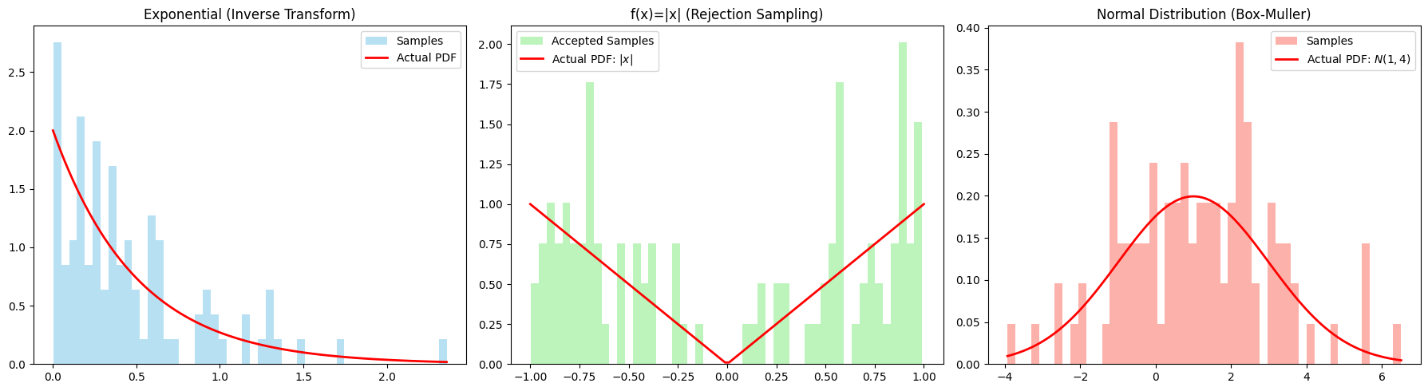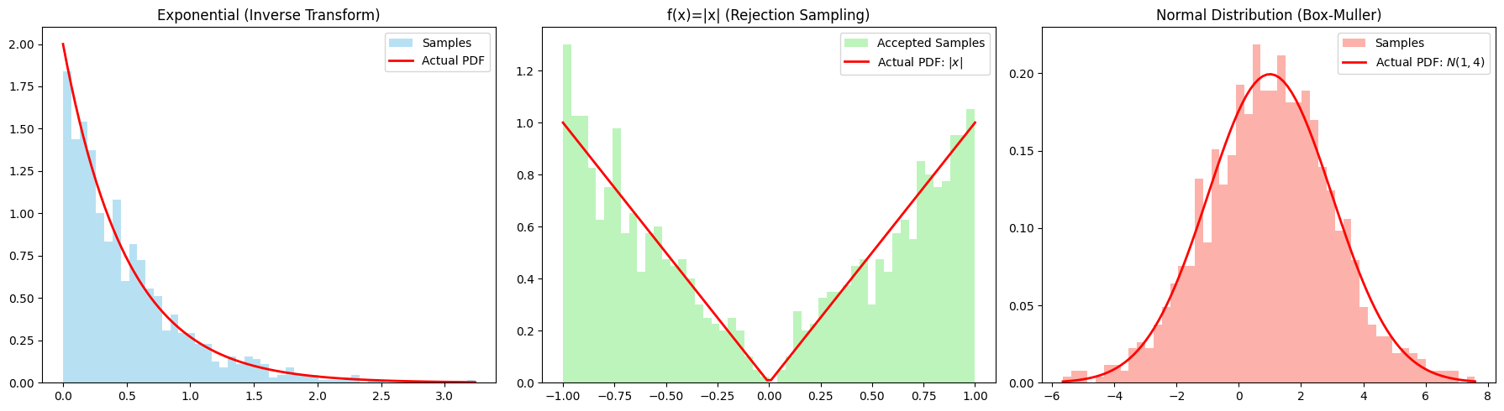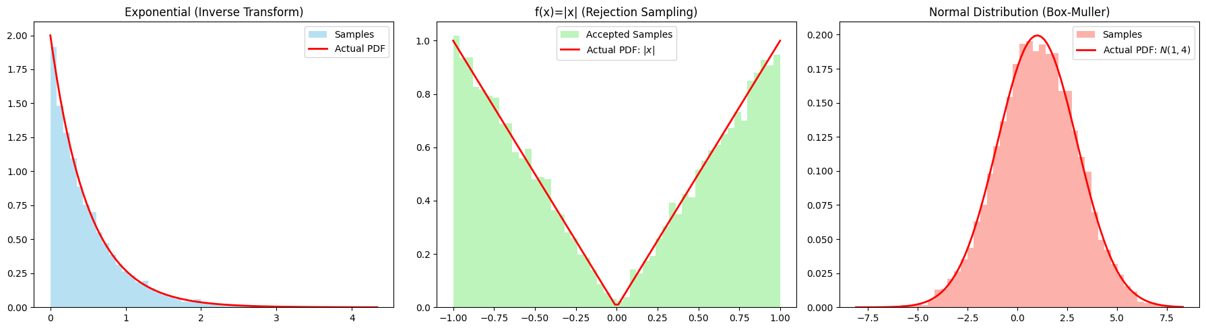
- Visual Alignment: At N = 100, the histograms are sparse and noisy, making it difficult to discern the underlying distribution. However, by N = 10,000, the histograms align almost perfectly with the actual Probability Density Function (PDF) curves for all three methods.
- Statistical Accuracy: The calculated estimations for Expectation (E(X)) and Variance (VAR(X)) converge toward the theoretical values as N increases.
Comparison Table: Theoretical vs. Estimated
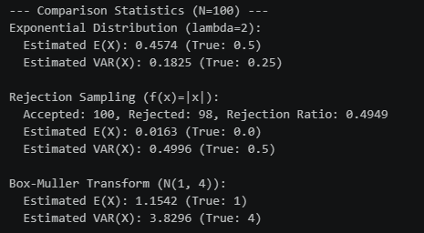
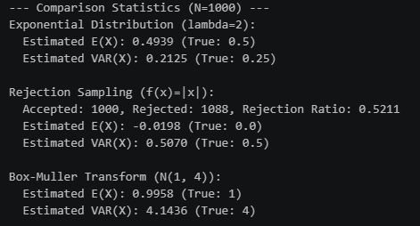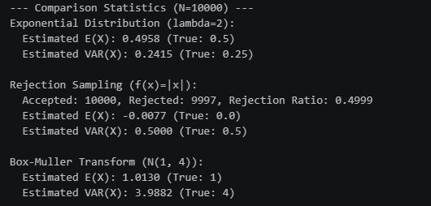
Part 2: Rejection Sampling Insights
- Rejection Rate Pattern: The rejection ratio consistently hovered around 0.50 (50%) across different trials. Specifically, at N = 10,000, the ratio was exactly 0.4999.
- Geometric Cause: This pattern exists because the target distribution f(x) = |x| on [-1, 1] has an area of 1, while the proposal distribution (a rectangle of width 2 and height 1) has an area of 2. Statistically, half the points generated in the "box" will fall outside the triangular area of |x|.
- Efficiency Proposal: To reduce the rejection rate, a tighter proposal distribution (envelope function) should be used. Instead of a flat rectangle, using a triangular proposal that more closely matches the V-shape of |x| would ensure that more samples are "accepted," making the sampler computationally faster.

Summary of Learning
Through the completion of Project 4, I have gained a comprehensive understanding of how probabilistic systems transition from mathematical theory to computational reality:
- Exact vs. Approximate Trade-offs: While Exact Inference (Elimination-ASK) provides the "true" answer, it is computationally intensive for large networks. Approximate Inference methods like Gibbs Sampling offer a scalable alternative that, with sufficient samples, provides highly reliable estimations.
- Sampling Dynamics: I learned that Likelihood Weighting is susceptible to high volatility when evidence is unlikely, whereas Gibbs Sampling (an MCMC method) tends to be more stable and accurate across varying sample sizes.
- Algorithmic Precision: Implementing the Inverse Transform and Box-Muller methods demonstrated how algebraic and geometric manipulations of uniform random numbers allow us to simulate complex continuous behaviors.
- Optimization Logic: The rejection sampling exercise highlighted the importance of choosing efficient "envelopes" for sampling, illustrating that the speed of an algorithm is often tied to how well it mirrors the geometry of the target problem.

